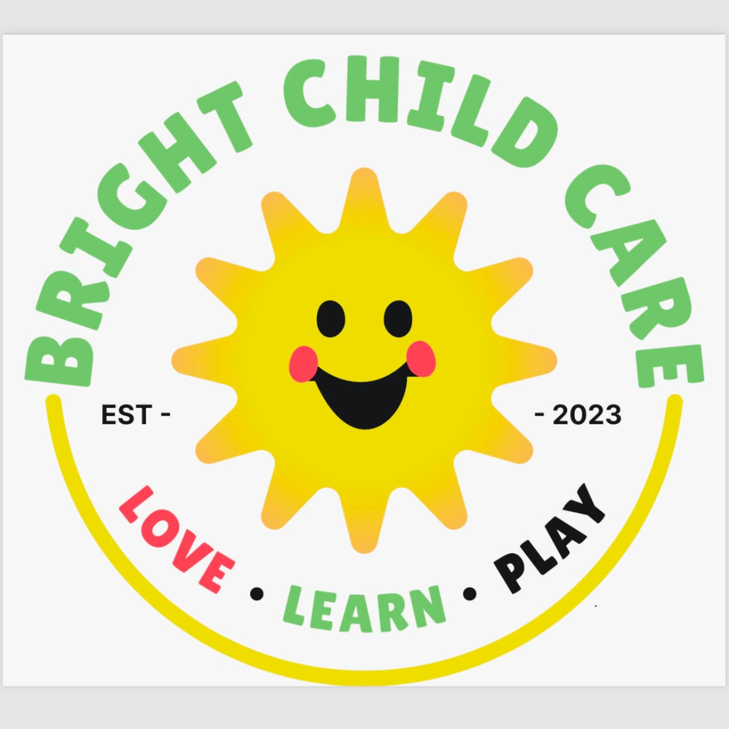
BRIGHT CHILD CARE
4635 W. 30th St.
Indianapolis, IN 46222
(317) 377-4711
brightchildcarecenter@gmail.com
www.brightchildcareindy.com

Parent/Guardian Handbook
February 2024 to July 2024

WELCOME
The purpose of this Parent Handbook is to outline the policies and procedures under which Bright Child Care will operate for the 2023-2024 school year.
Bright Child Care will operate Monday to Friday from 7am to 6pm. Activities within the program will be monitored and adjusted accordingly, in consultation with parents, staff and management to promote ongoing development.

DIRECTOR MESSAGE
On behalf of the Al-Barakah Foundation Inc. community, I would like to welcome you and your family to Bright Child Care daycare! We have been striving to provide a daycare that can give our surrounding community members a nurturing, safe, and faith-based environment for your young ones age 6 weeks to 5 years.
As someone who has been raised and involved in the Indianapolis community, I am eager to deliver high quality child care for our community. I have over 10 years of experience working with children in public schools, private schools, daycares, and clinics. I strive to deliver a high-quality environment for our children to develop their young minds in a holistic, faith-based, and academically successful way.
I cannot wait to meet all of you and create a stronger community together while protecting and inspiring -our young children’s minds.
-Sumayyah Muhammad

HISTORY
Bright Child Care was founded by Al-Barakah Foundation Inc. community in 2022 when they raised enough money to purchase the daycare facility next door to provide child care that was faith-based for our community. In 2023, Al-Barakah volunteers and staff worked diligently in renovating the building and preparing for the opening off Al-Barakah Foundation’s daycare, Bright Child Care, just steps away from Al-Barakah Masjid and under the umbrella of Al-Barakah Foundation, Inc.

MISSION
Our mission is to maximize each child's potential by providing an active, collaborative, and faith-based learning environment where children, families and educators become empowered for social, emotional, religious, and academic success.

VISION
Our vision is a world where every child meets their maximum potential. We aim to create a nurturing environment where faith, diversity, and progressiveness intersect. We believe in fostering a sense of community, respect, and personal growth while embracing the fundamentals of Islam, culture, and various backgrounds.

OUR PHILOSOPHY
At Bright Child Care, we provide a nurturing and faith-based environment where your child can grow, learn, and thrive. We offer a nurturing and safe environment for children ages 6 weeks to 5 years. Located in the heart of the west side, we provide easy access to group salah and Islamic classes at Al-Barakah Masjid just steps away. Our resolute staff is committed to offering quality care and teaching Islamic manners, duaas, and guidelines. Our faith-based daycare embraces children of all faiths and backgrounds while teaching basic Islamic principles and manners.

Children: Are entitled to a safe and nurturing environment with a schedule of routines that best meet the individual needs of each child in our care. Each child is treated with respect as a valuable individual.

Parents: Are entitled to individual respect, support, and quality care for their children.

Staff: Are entitled to work in an environment which recognizes and respects their training, skills, and commitment to childcare.

GOALS OF BRIGHT CHILD CARE
Faith Integration
- Respectful Exposure: We introduce children to Islam through age-appropriate stories, celebrations, and activities. This exposure helps children develop an understanding and appreciation for Allah (God), community, brotherhood/sisterhood, compassion, and discipline.
- We also encourage children to explore their spirituality in ways that resonate with their families’ beliefs. We celebrate common values such as kindness, compassion, and empathy.
- Interfaith Dialogue: As children grow, we facilitate open discussions about faith, fostering an environment where questions are welcomed, and diverse viewpoints are respected.

Progressive Curriculum
1. Holistic Development: Our curriculum integrates faith-based teachings with progressive
educational methods, emphasizing cognitive, emotional, social, and physical development.
2. Critical Thinking: We promote age-appropriate critical thinking by encouraging children to ask
questions, explore ideas, and engage in constructive discussions about ethical and moral issues.
3. Social inclusion: Our curriculum addresses social justice topics, teaching children about
equality, inclusion, and the importance of making a positive impact in their communities.
Diversity:
4. Cultural Exploration: Through celebrations, crafts, and stories, we introduce children to
diverse cultures, helping them develop a global perspective.

Community Engagement:
1. Community Service: We engage children in age-appropriate community service projects,
nurturing a sense of responsibility and empathy for others.
Open Communication:
1. Family Involvement: We encourage families to share their faith traditions, values, and
cultural practices with us, enriching our understanding of each child’s background.
2. Transparent Dialogue: We maintain open lines of communication with families, discussing
our faith-based and progressive approach and addressing any questions or concerns.

WAITLIST Policy:
A waitlist will be formed when full enrollment has been reached in the daycare. Procedure:
1. The number of children in the daycare is governed by Licensing Regulations.
2. Children are accepted into the daycare on a first come basis.
3. The child’s name is entered on the computer according to the date of the initial phone call.
4. When an opening for the daycare occurs the Director will contact the parents or guardians of
the first child on the waiting list by telephone.
5. Children will be removed from the waitlist upon the following reasons: Parents or guardians
request, the family has moved away, or phone number is out of order.

DEFINITIONS:
Infant: 0 months to 12 months
Toddler: 12 months to 36 months
Preschoolers: 3 years old to 5 years old

TUITION PER CHILD: (UPDATED 02/05/24, ACTIVE THROUGH 07/31/24)
Infants: $300/week
Toddlers: $225/week
Preschoolers: $150/week

ATTENDANCE POLICY:
Regular attendance is extremely important for your child to settle in well.
Routine becomes part of your child’s day. You are welcome to visit your child in the daycare at
any time.

ARRIVAL PROCEDURE:
Parents will:
1. Notify the daycare staff if your child is not coming in.
2. Upon arrival, parents must sign their child ’ren in properly before leaving the child care.
3. Put all diaper bags and extra clothing or other belongings in the child’s assigned space.
4. Label all belongings that might occupy a shared space; things like bottle, pacifiers, diaper
packages.
5. Take time to settle your child and say goodbye.
6. Inform teachers and staff of any information needed to administer proper care.

DEPARTURE PROCEEDURE:
Parents must:
1. Sign their child out PROPERLY.
2. Make personal contact with a staff member before leaving with their child.
3. Staff will: Phone parents or guardians when a daycare child has missed three consecutive
days of daycare.
4. Staff will: establish with parents or guardians the reason for the absence so documentation
can be made.
5. If after two weeks Staff have been unable to reach the parents, the child will be dismissed
from the program.

SAFE TRANSPORTATION POLICY
We do not provide transportation at Bright Child Care.

STAFFING POLICY
Daycare personnel will adhere to State rules and regulations. At times, the daycare will be
closed for staff training and professional development. There will be NO fee deductions for
these closures as it is enhancing the quality of care each child will receive.

LATE PICKUP POLICY
Late pickup should be rare and beyond parent’s control. Habitual late pick-ups breach the cooperative relationship between provider and clients and may result in termination of contract. The late charge is assessed of $1.00 for every one minute late if this is more than an occasional occurrence. Please be courteous and respectful of staff’s schedules and arrive on time.

OPEN DOOR POLICY
We have an open-door policy for all parents. This means you can stop by during business hours unannounced to observe your child, program activities, and equipment without having to secure prior approval.

ILLNESS WHILE IN CARE
For the health and safety of your child in care, please do not bring your child to daycare sick. If you are not sure if your child should be brought to daycare, then please call and check with us. The child must be feeling well enough to participate in activities. If a child becomes ill during daycare hours: the child will be moved away from the other children, the parents will be contacted to pick up their child. Parents need to pick up their sick child within one hour of being notified. If parents are not available, the emergency contact person will be notified. Note: once the child is removed from the daycare because of illness, they may not return to our daycare until symptoms requiring removal are no longer present.

EXCLUSION POLICY
Any child must be completely free of any symptoms before returning to daycare. If the child is taking antibiotics for an illness, the child may return to daycare after the initial 24 hours of beginning antibiotics only if he or she has no fever under 100F, no longer contagious, and is otherwise feeling well enough to participate in our daily schedule.

SUPERVISION POLICY
Staff must always provide effective supervision that ensures the safety, well-being, and development of the children in our program. We believe that effective supervision is more than just watching children; it is about using strategies that promote effective supervision practices and create safe environments for the children we care for. These strategies reduce the risk of harm to children by preventing injuries and accidents.
Effective supervision is one of the most important tasks caregivers and staff must perform throughout the day. We care for the most precious treasures – children! All Staff must avoid conducting activities that may draw their attention away from active supervision. Examples of such activities include administrative tasks, texting, reading, using the phone, and visiting co-workers. Should such activities be observed, the Program Director will meet with staff to discuss the issue and a written warning will be documented in the staff’s file. Three written notices regarding “supervision related issues” will result in dismissal.

PICK-UP PROCEDURES
Parents or other authorized adults are required to sign their child out of care on the electronic tablet located outside the classroom doors. Once a parent signs their child out, the parent is then solely responsible for supervising their child while on the premises. Parents are required to manage all business issues prior to signing out their child and are required to exit the building once they have signed their child out of care. The classroom teacher will be able to briefly discuss the matter with you or another authorized adult at pick-up. However, should you feel it necessary to have an in-depth discussion or meeting, it is most appropriate to schedule the meeting for a later date because the teacher is responsible for supervising the remaining children in the classroom.

PAYMENT
Out of pocket payments need to be made at the beginning of the month. They will not be refunded unless for due cause after a meeting with the staff and parents has been had.

CONCLUSION
At Bright Childcare Center, our unique approach combines faith, inclusivity, and progressiveness.
to provide children with a solid foundation for personal growth, cultural awareness, and
compassionate engagement with the world around them. We are committed to fostering an
environment where children and families from all backgrounds can thrive, learn, and celebrate.
their shared humanity.

